Skill Tracker

# Author: Ayushi Jain

About Project:

Created the single page solution i.e. Skills Tracker to keep track of employee skills.

The Skills Tracker is a Single Page Application (SPA). Using this internal portal John Dempsey who is an new age HR Academic Manager will be able perform following operations:

* **Search Associate**: John will be able to search associate with following criteria’s:

1. Search by associate name
2. Search by associate ID
3. Search by associate Email ID
4. Search by Mobile Number
5. Search by Skills

* **Add new Associate:** John will be able to add new associate and its respective Full Stack Development Skills.
* **Edit, Delete & View Associate:** The associate which is searched can be updated, deleted and viewed.
* **Add Skill**: It will allow John to add new skills so that it can be used in “Add New Associate” page.

Along with this SPA I have added other microservices such as:

* **Eureka Server:** Eureka Server is an application that holds the information about all client-service applications. Every microservice will register into the Eureka server and Eureka server knows all the client applications running on each port.
* **Admin Server:**  is an application used to manage and monitor microservice application. To handle such situations, CodeCentric Team provides a **Spring Boot Admin** UI to manage and monitor all your **Spring Boot** application Actuator endpoints at one place.
* **Zuul Proxy and Load Balancing:** **Zuul** is a JVM based router and serverside **load balancer** by Netflix. It is a gateway application that handles all the requests and does the dynamic routing of microservice applications. **Load balancing** refers to efficiently distributing the incoming network traffic across a group of backend servers (multiple instances of the service).

**Tools and Technologies Used:**

1. Spring Framework
2. Java 1.8
3. Maven
4. H2 database
5. Thymeleaf
6. JPA
7. Bootstrap CSS
8. Intellij IDE

**Flow and functionality of Skill Tracker:**

1. **List of all Employees**

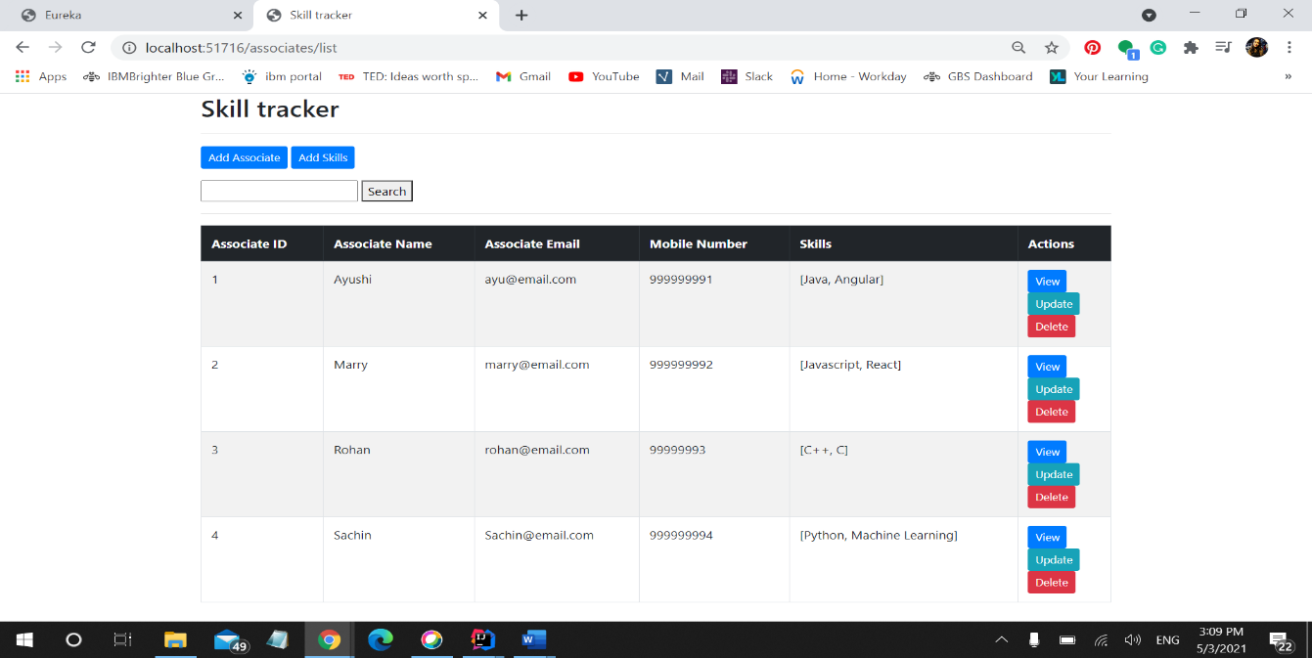

1. 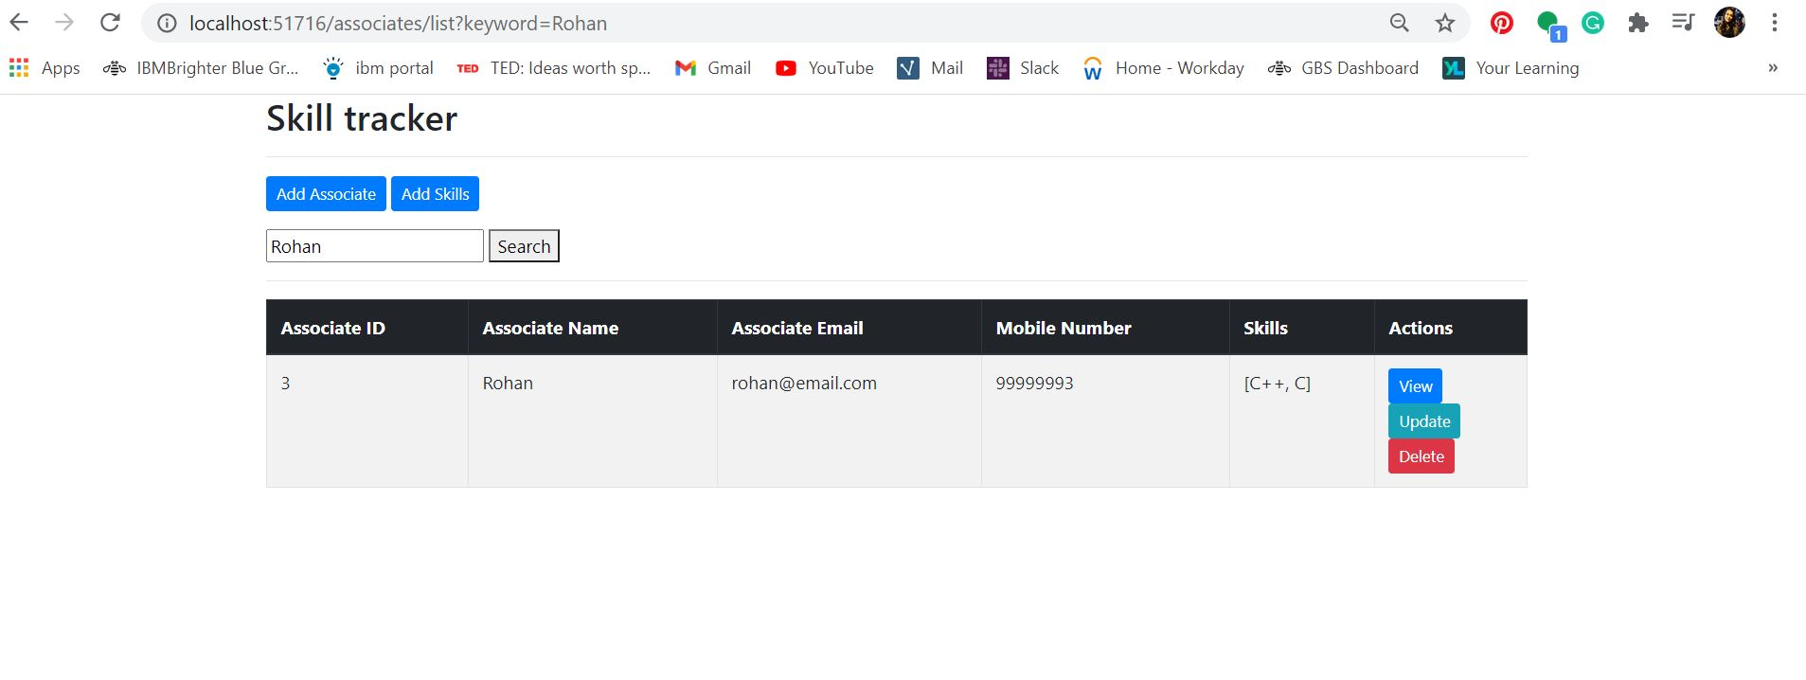**Search by Name/ID/Email/Mobile Number/Skills**
2. 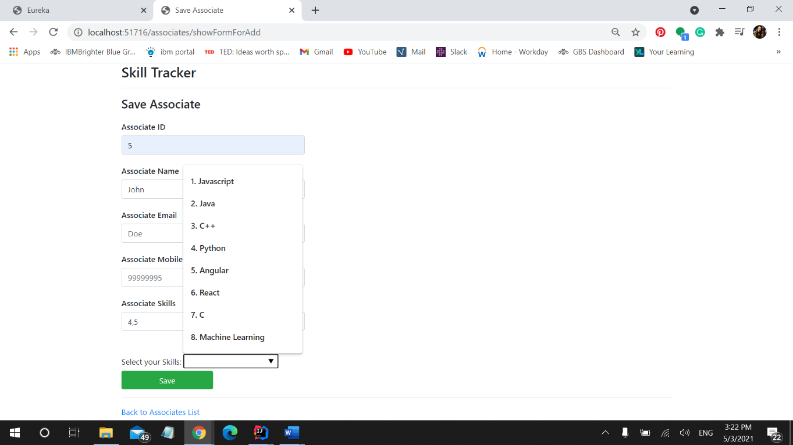**Add new Associate**
3. 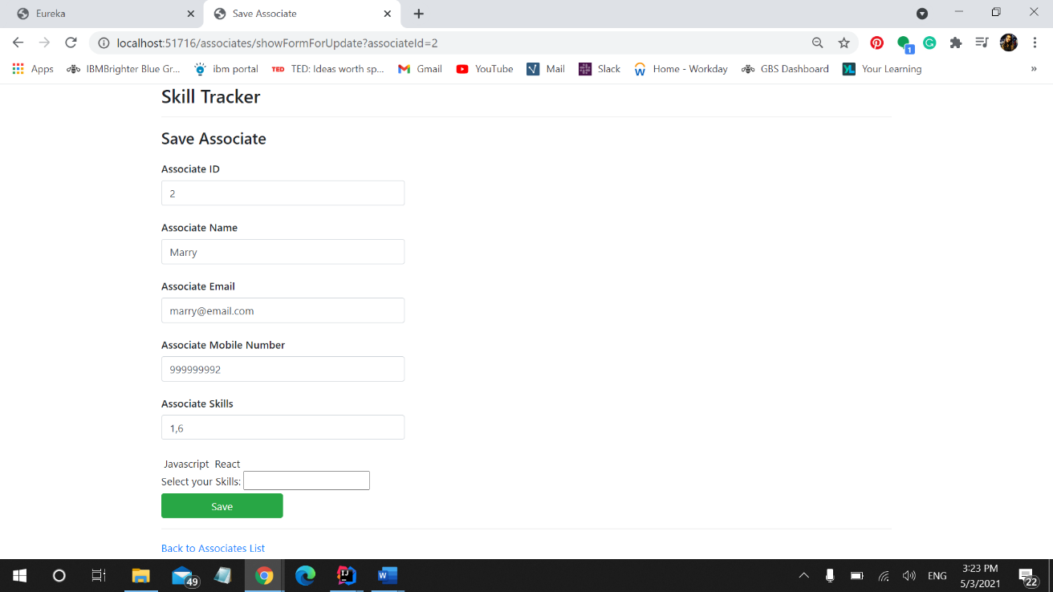**Edit Associate**

1. **View Associate**

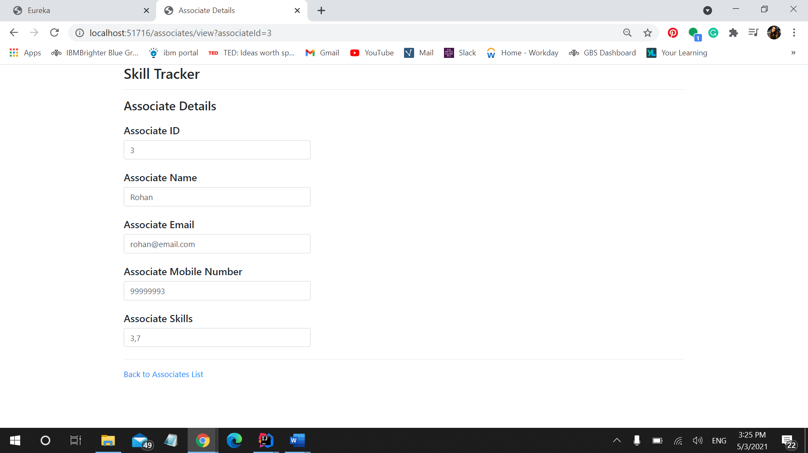

1. 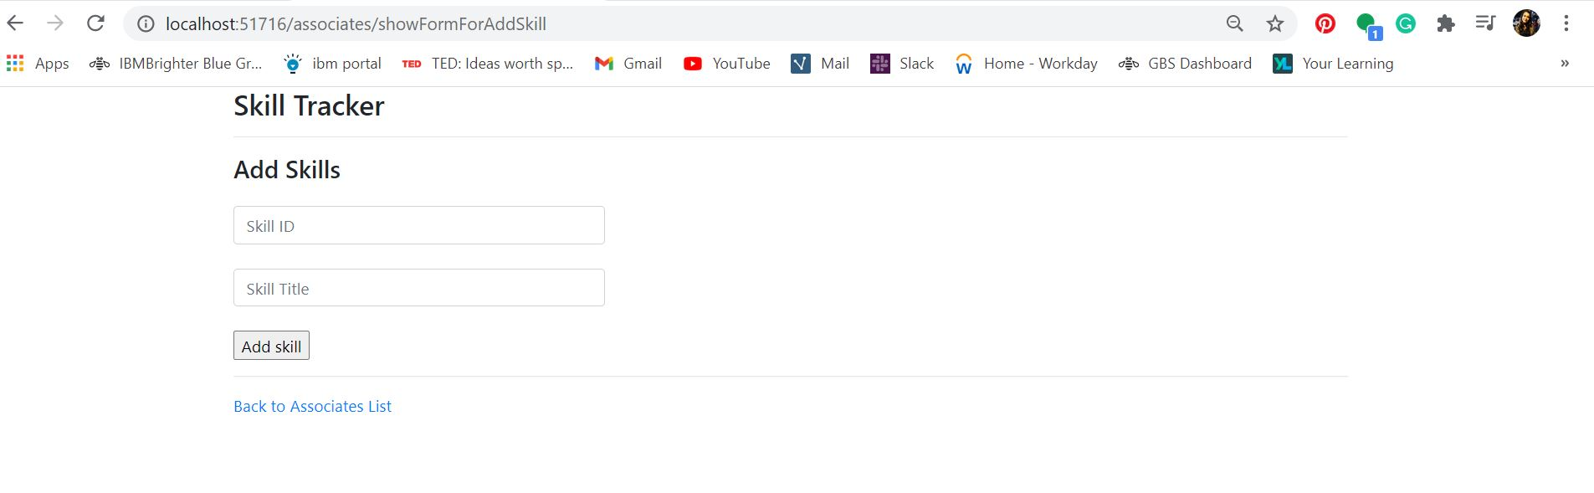**Add new Skill**
2. 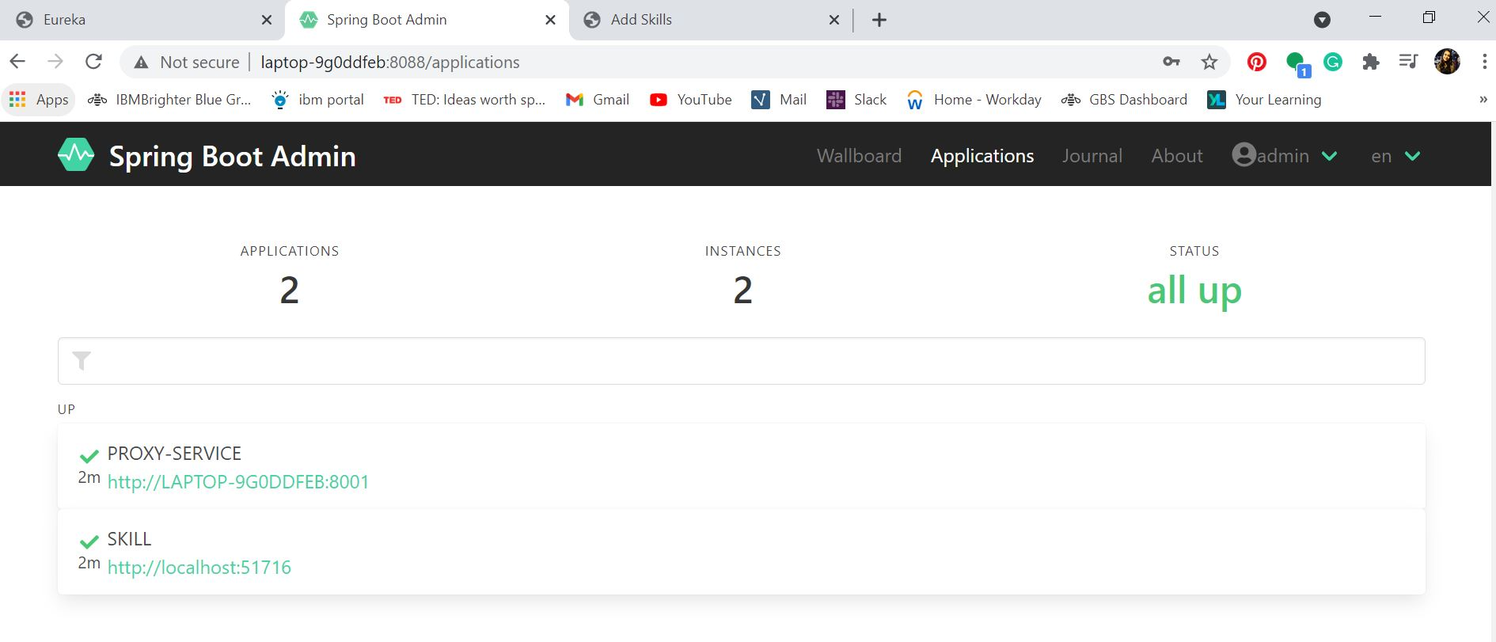**Admin Server**
3. 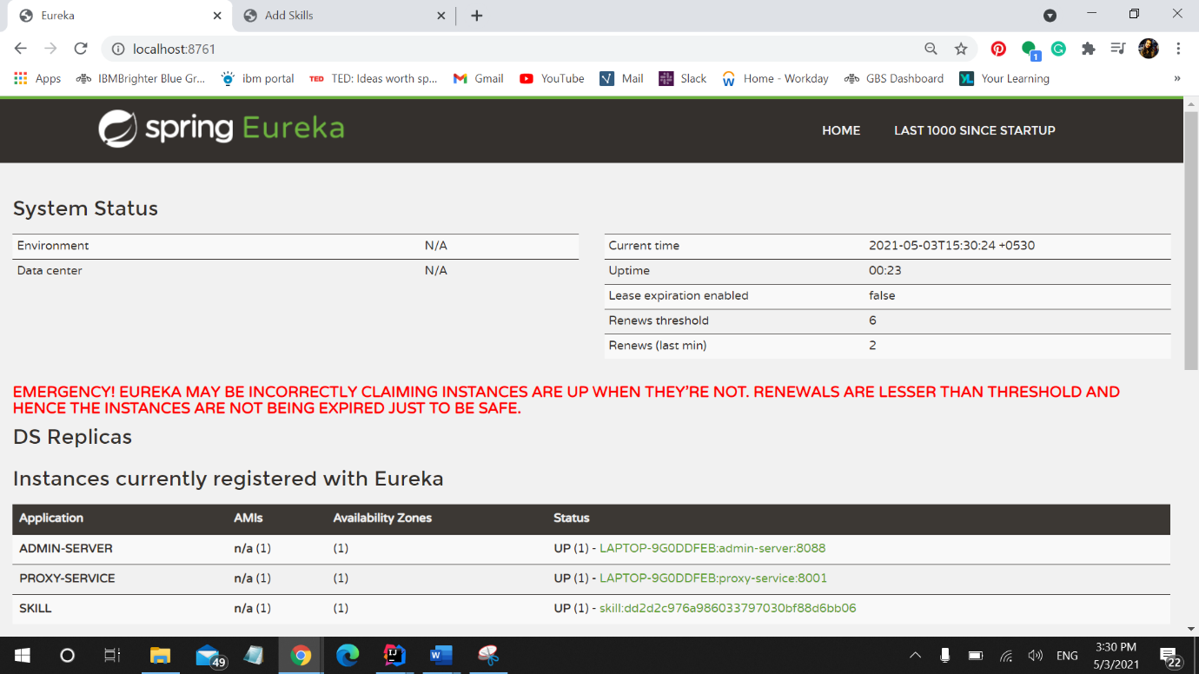**Eureka Server**
4. **Zuul Proxy and Load Balancing**

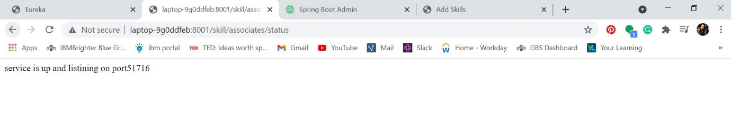

Google Drive link to project files:

<https://drive.google.com/drive/folders/1Bxdw1lqbSqnMygqfOFuitGZo7LH9znAe?usp=sharing>

## THANK YOU!